**CHIKKANNA GOVERNMENT ARTS COLLEGE**

**TIRUPUR-641602**

**(AFFILIATED TO BHARATHIAR UNIVERSITY)**



**TEAM MEMBERS NAME :**

SANJAYKUMAR.R(2022K0047)

RAMANATHAN.G(2022K0042)

GOWTHAM.C(2022K0021)

MOHAN.S(2022K0034)

SATHISKUMAR.G(2022K0052)

**DEPARTMENT OF COMPUTER SCIENCE**

**CHIKKANNA GOVERNMENT ARTS COLLEGE**

**NAAN MUDHALVAN PROJECT WORK**

**(AFFILIATED TO BHARATHIAR UNIVERSITY)**

**TIRUPUR-641602**

### TITLE : Thyroid Disease Classification Using ML

This is to certify that this is a bonafide record of work done by the above students of III B.Sc (CS) Degree **NAAN MUDHALVAN PROJECT** during the year ……….

Submitted for the Naan Mudhalvan  project work held on………….20

**CLASS TUTOR HEAD OF THE DEPARTMENT**

**INDEX**

|  |  |  |  |
| --- | --- | --- | --- |
| **S.No.** | **Date** | **Contents** | **Page No.** |
| **1** |  | PROBLEM SELECTION |  |
| **2** |  | IDEATION |  |
| **3** |  | REQUIREMENT ANALYSIS |  |
| **4** |  | PROJECT DESIGN |  |
| **5** |  | PROJECT PALNNING PHASE |  |
| **6** |  | PROJECT DEVELOPMENT PHASE |  |
| **7** |  | RESULT(INPUT & OUTPUT) |  |

**PROBLEM SELECTION**

1. Predicting thyroid disease using machine learning is an interesting and important project that can have significant implications in the field of healthcare. Here are some steps you can follow to select a suitable project:
2. Research existing work: Before starting any project, it's important to research existing work in the field. Look for similar projects that have been done before and see what approaches were used. This will help you understand the current state-of-the-art and identify any gaps in the literature that your project can address.
3. Define the problem: Once you have a good understanding of the current research, define the problem you want to solve. For example, you could focus on predicting the risk of developing thyroid disease in a particular population or predicting the progression of the disease in patients who have already been diagnosed.
4. Gather data: In order to train a machine learning model, you will need a dataset. Look for publicly available datasets or consider collecting your own data. Make sure that the data you use is of high quality and is representative of the problem you are trying to solve.
5. Train and evaluate the model: Once you have chosen an algorithm, train the model on your dataset and evaluate its performance using appropriate metrics such as accuracy, precision, recall, and F1 score. If the model's performance is not satisfactory, consider tweaking the algorithm or using a different one.
6. Deploy the model: Once you have a model that performs well, deploy it in a real-world setting. This could involve integrating it into an electronic health.

**IDEATION**

1. Collect Data: Collect data from various sources, including medical records, patient information, and clinical studies. Ensure that the data is in a structured format and that it contains all the necessary features for building a model.
2. Preprocess the Data: Once you have the data, preprocess it by cleaning, normalizing, and transforming it into a format that can be used by a machine learning model.
3. Feature Selection: Choose the relevant features that will be used to predict the thyroid disease. These features can include patient demographics, lab test results, and medical history.
4. Choose a Model: Choose an appropriate machine learning algorithm that will be used for prediction. There are various algorithms available, including decision trees, random forests, and support vector machines.
5. Train the Model: Use the preprocessed data and the chosen algorithm to train the model. Split the data into training and testing sets to evaluate the model's accuracy.
6. Evaluate the Model: Evaluate the model's performance using different metrics such as accuracy, precision, recall, and F1-score.
7. Deploy the Model: Finally, deploy the model into a production environment where it can be used to predict the thyroid disease of new patients.

**REQUIREMENT ANALYSIS**

**Data collection:**

Gather a large dataset of patient information, including demographics, medical history, symptoms, lab test results, and imaging data (if available). The dataset should include both positive and negative cases of thyroid disease to ensure the model is trained on a balanced dataset.

**Data preprocessing:**

Clean the data, remove any missing or irrelevant information, and encode categorical variables.

**Feature select:**

Identify the most important features that contribute to the prediction of thyroid disease.

**Algorithm select:**

Select the appropriate machine learning algorithm for the task, such as logistic regression, decision trees, random forests, or support vector machines.

**Model training:**

Split the dataset into training and validation sets, train the model on the training set, and evaluate the performance on the validation set. Adjust the model hyperparameters to optimize performance.

**Model evaluation:**

Evaluate the model's performance using metrics such as accuracy, precision, recall, and F1-score. Use cross-validation to ensure the model's generalizability to new data.

**Model deployment:**

Deploy the trained model in a user-friendly interface, such as a web application or mobile app, to enable healthcare professionals to make accurate predictions of thyroid disease in their patients.

**Maintenance and updates:**

Regularly update the model with new data and retrain as necessary to ensure the accuracy of the predictions.

**PROJECT DESIGN:**



**PROJECT PLANNING PHASE**

**Define the problem:**

Define the problem you want to solve. For example, you may

want to build a model that can accurately predict the risk of thyroid disease in patients based on certain clinical and demographic features.

**Gather data**:

Identify the data sources that can be used to build the machine learning model. This may involve gathering data from electronic health records, medical imaging, or patient surveys.

**Choose a machine learning algorithm:**

There are several machine learning algorithms that can be used to build a predictive model. You will need to choose an algorithm that is appropriate for your data and problem.

**Train the model:**

Once you have chosen an algorithm, you will need to train the model on the data. This involves dividing the data into training and validation sets, and using the training set to optimize the model's parameters.

**Evaluate the model**:

After training the model, you will need to evaluate its performance on the validation set. This will give you an idea of how well the model will perform on new data.

**Deploy the model:**

Once you have a model that performs well on the validation set, you can deploy it in a clinical setting. This may involve integrating it into an electronic health record system, or creating a standalone application.

**PROJECT DEVELOPMENT PHASE**

**Data collection and preparation:**

This involves gathering relevant data from various sources and preparing it for use in machine learning algorithms. In the case of thyroid disease prediction, this might include medical records, lab results, and patient demographics.

**Feature selection and engineering:**

Once the data has been collected, the next step is to select the most relevant features (i.e., variables or attributes) that are likely to be predictive of thyroid disease.

This might involve domain expertise from medical professionals, as well as statistical techniques such as correlation analysis or principal component analysis.

**Model selection and training:**

With the features selected, the next step is to choose an appropriate machine learning algorithm to use for prediction. This might include traditional models such as logistic regression or more advanced methods such as deep learning

**Model evaluation and tuning:**

Once the model has been trained, it is evaluated using various metrics such as accuracy, precision, and recall

**Deployment and monitoring:**

Finally, the trained and validated model can be deployed for use in clinical settings. Ongoing monitoring and evaluation of the model's performance are critical to ensure that it remains accurate and effective over time.

**RESULT**

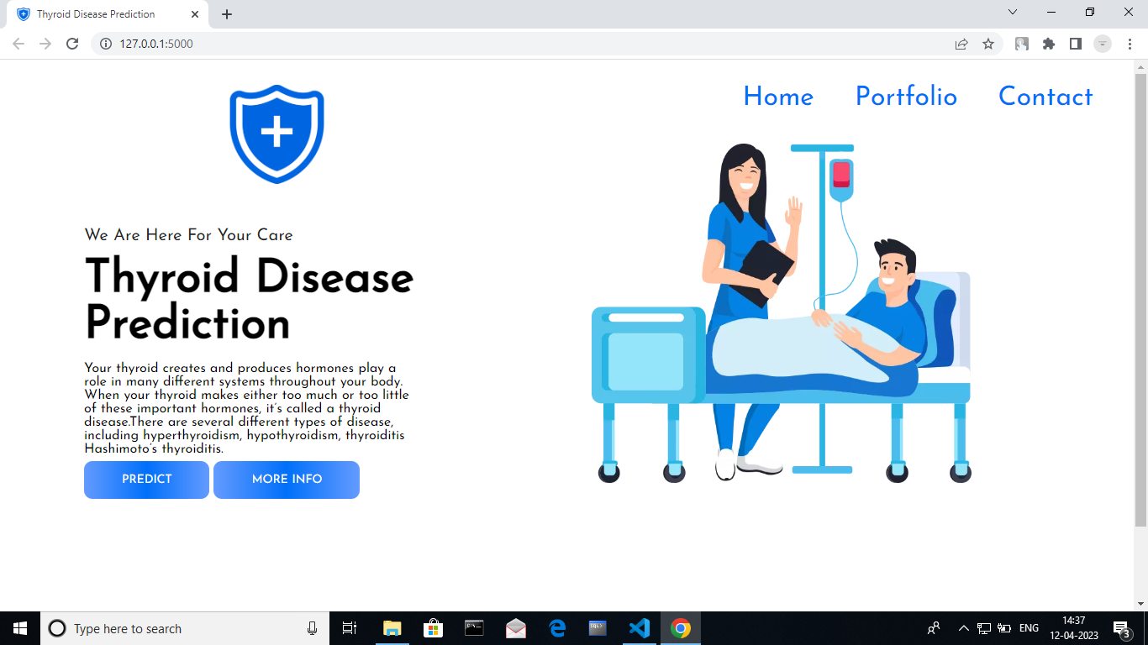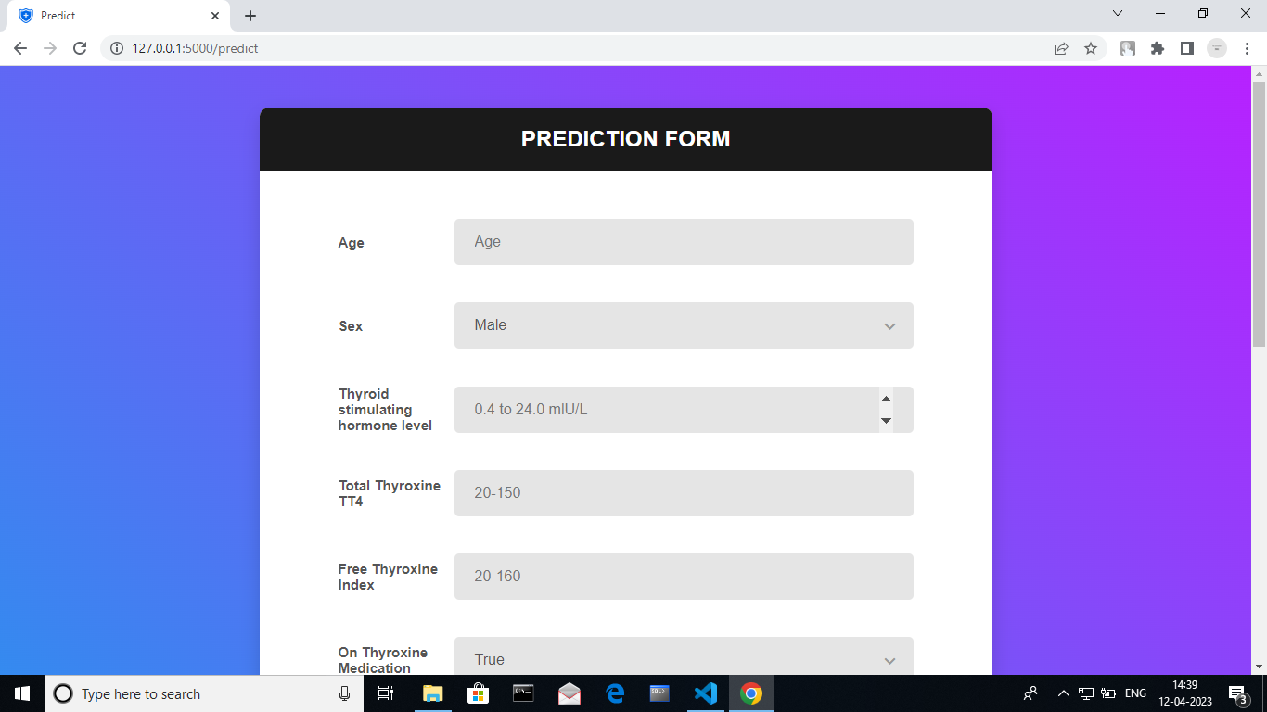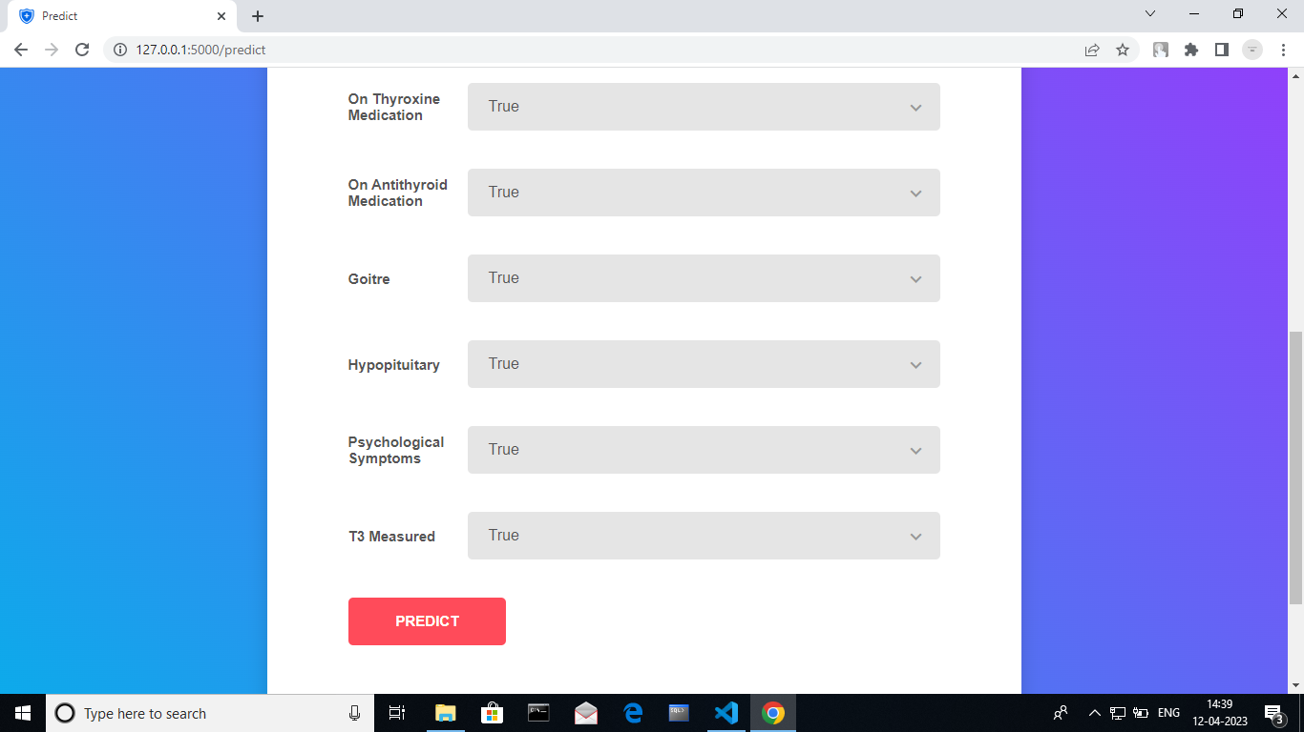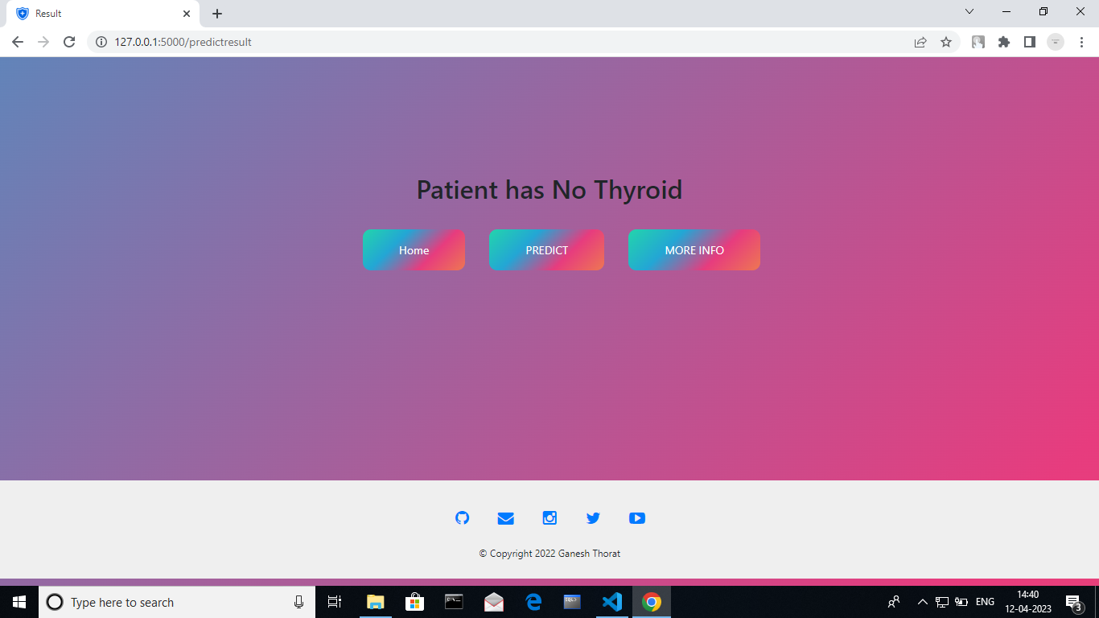

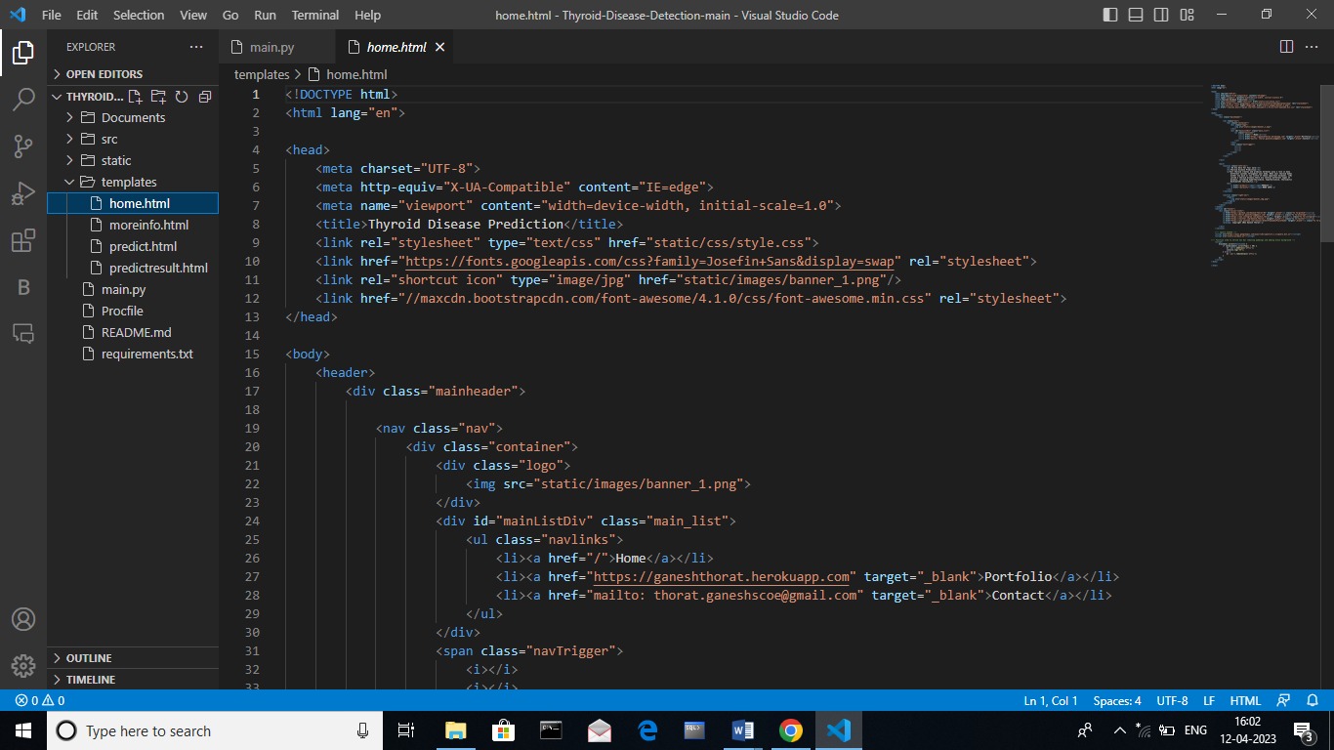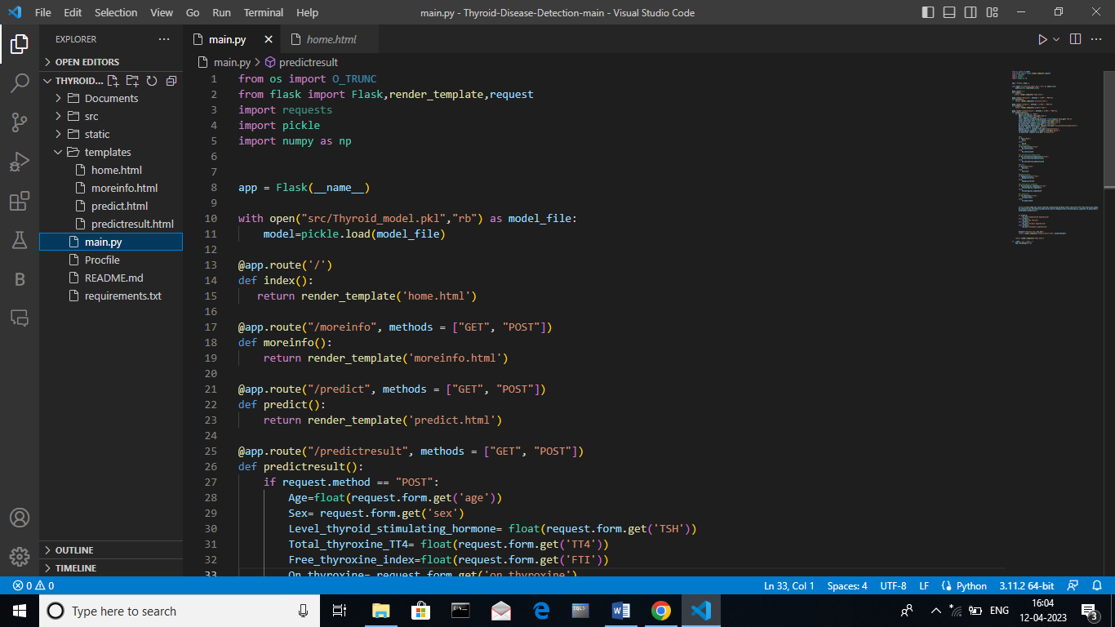

**SAMPLE CODING**